**Data Structures and Algorithms**

**Lab Report**

**Lab03**



|  |  |
| --- | --- |
| Group Members Name & Reg #: | **Muhammad Haris Irfan**  **(FA18-BCE-090)** |
|  |  |
| Class | Data Structures and Algorithms CSC211 (**BCE-3B**) |
| Instructor’s Name | Dilshad Sabir |

**In Lab Tasks**

**Question no: 1**

‘Inserting nodes at the end’ and ‘inserting node after a given node’ are already implemented in ***‘SinglyLinkedList.c’***. Your task is to implement ‘**i*nsert at the beginning***’ and ‘***insert before***’ functions in the file ***‘SinglyLinkedList.c’***.

**Solution:**

The code of the following code is attached below:

**INSERT AT THE BEGINNING**

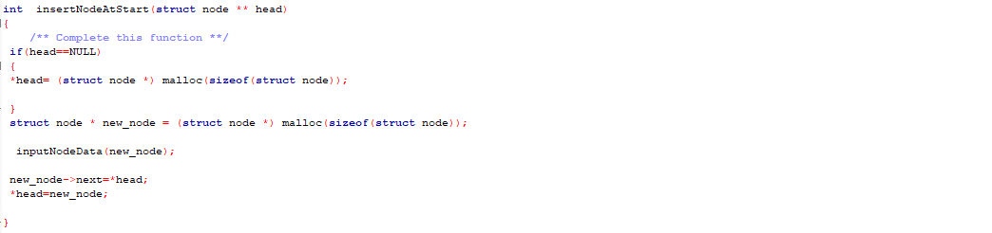

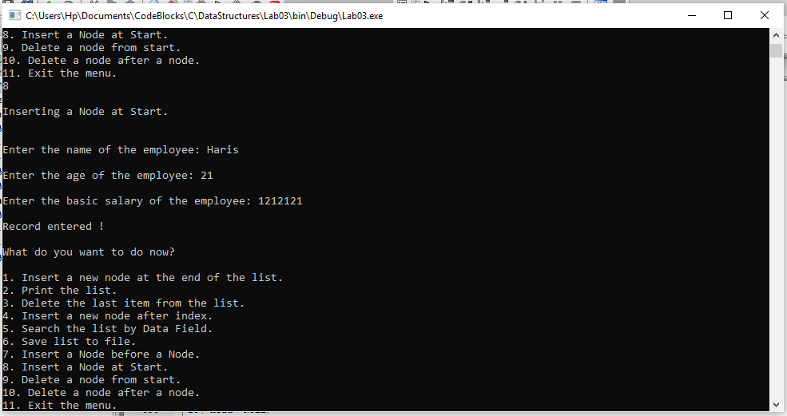the result is attached below,

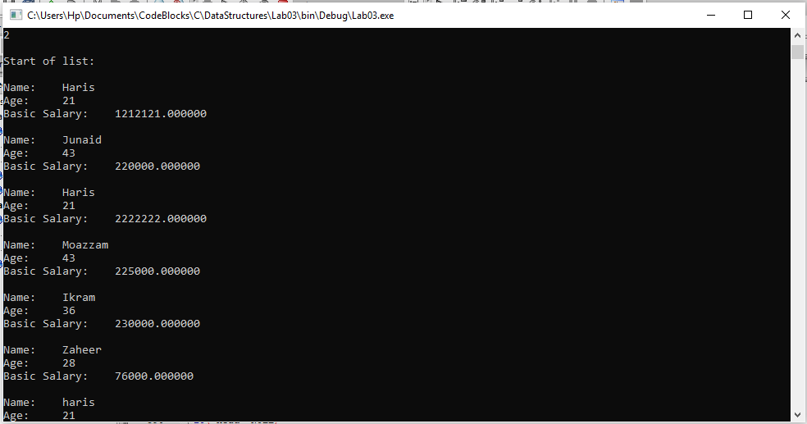

**INSERT BEFORE A NODE**

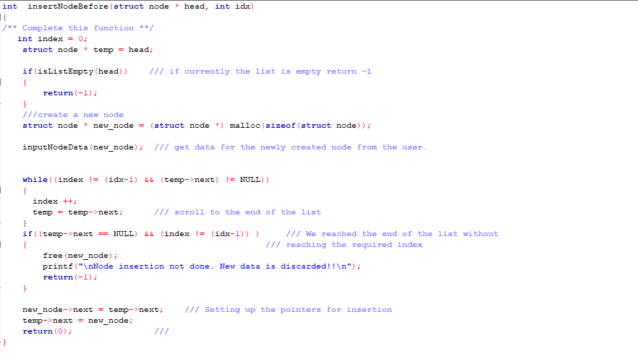The code of the following code is attached below:

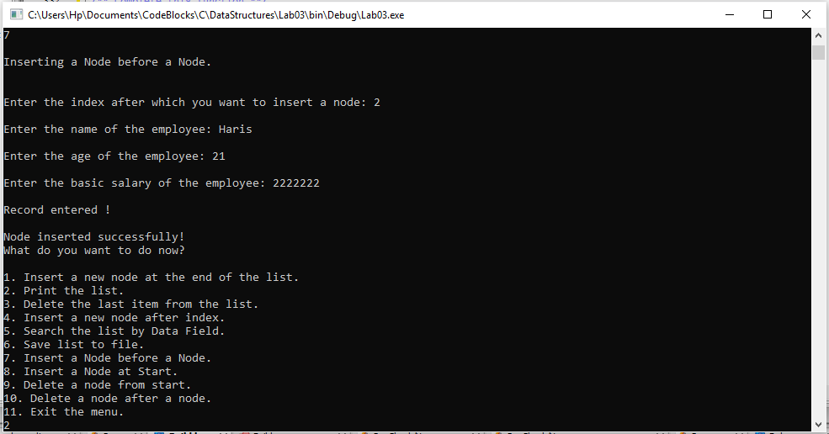the result is attached below,

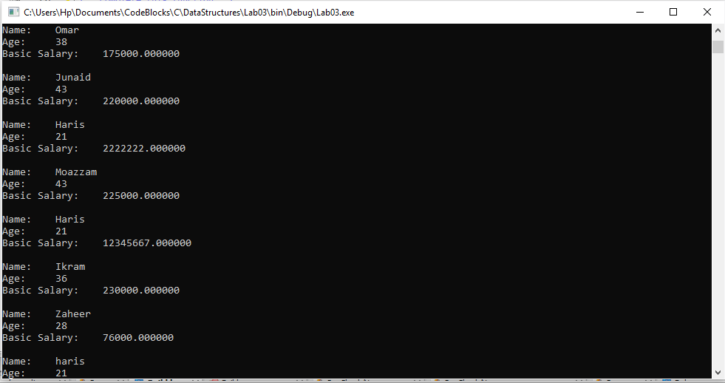

-------------------------------

**Question no:2**

Deleting a node from the end is already implemented in ***‘SinglyLinkedList.c’*** your task is to implement ‘***delete from beginning***’ and ‘***delete after***’ a given node.

Solution

The code is shown below,

DELETING FROM THE BEGINING

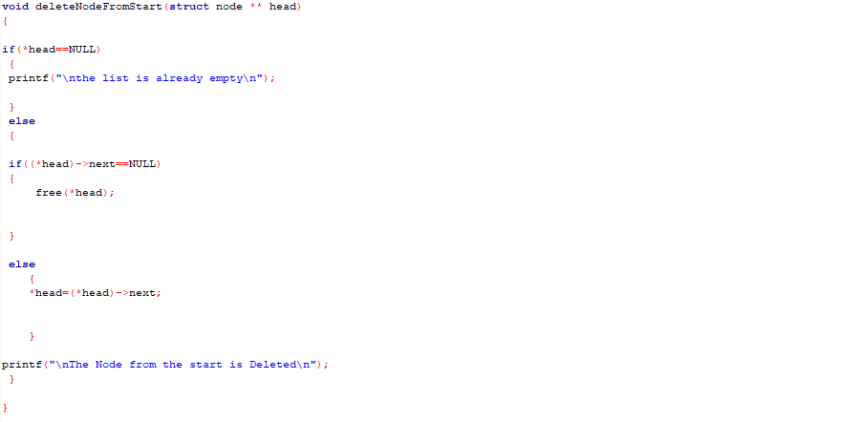

The Result of the following code is attached below:

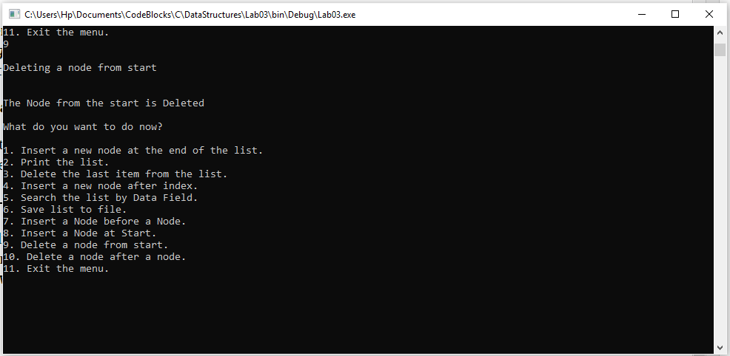

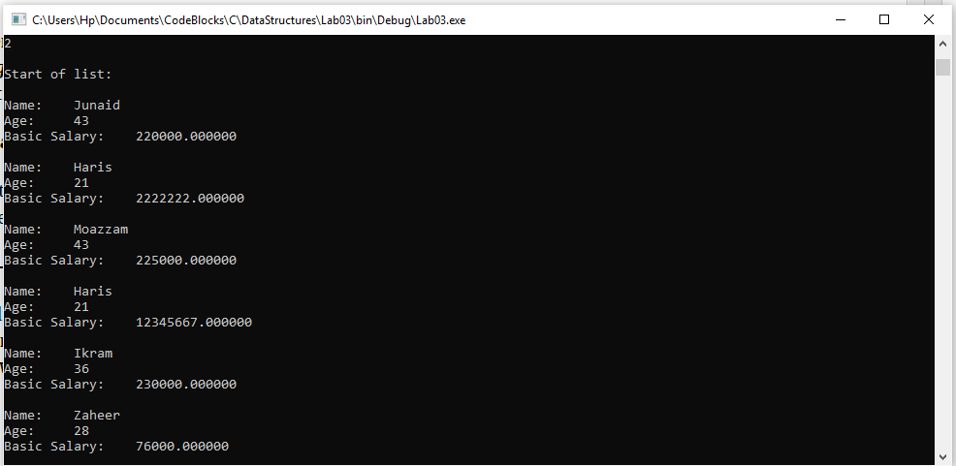

DELETING AFTER A NODE

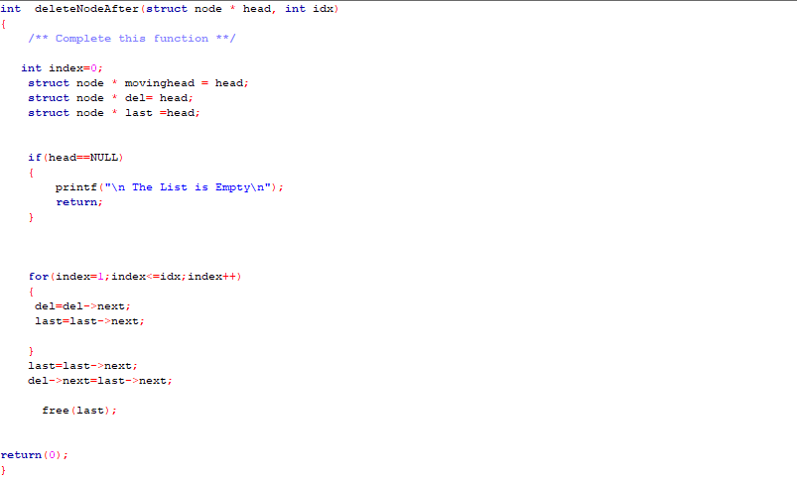

the Result of the following code is attached below:

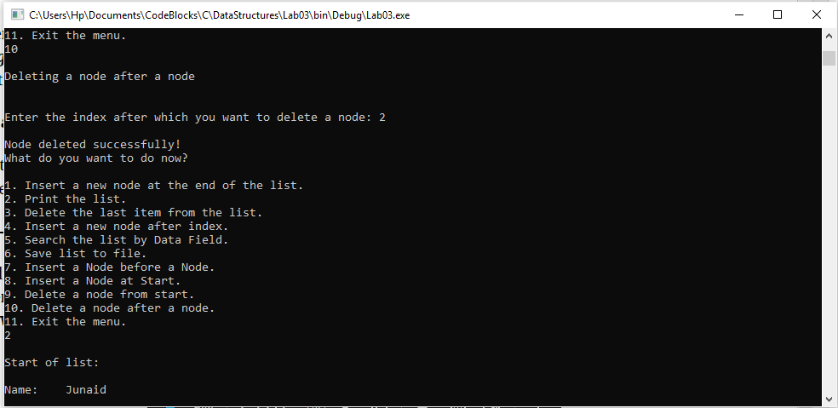

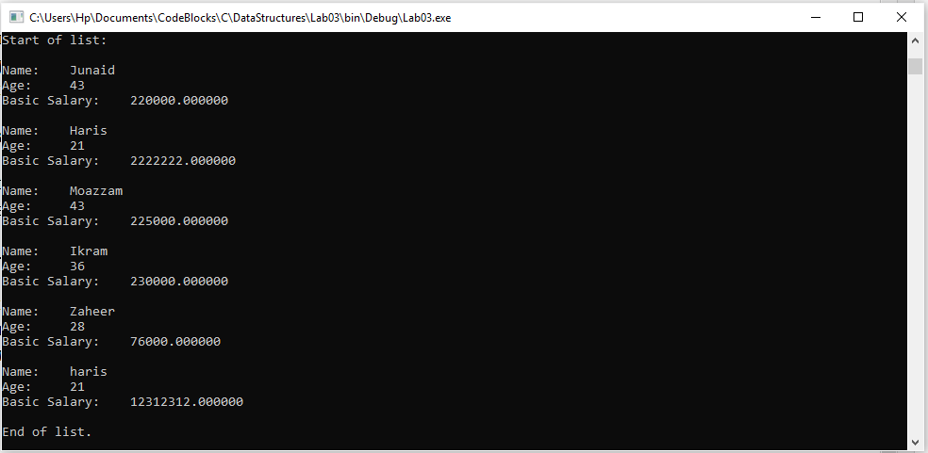

------------------------------

**POST LAB**

**Question no:3**

Reading database from a file on the hard disk is already implemented. Your first task is to study and understand this implementation. Then you will have to implement the write to file function ***‘saveListToFile()’.*** Submit a report on your implementation.

Solution

The code is shown below for the given program and its results are given below,

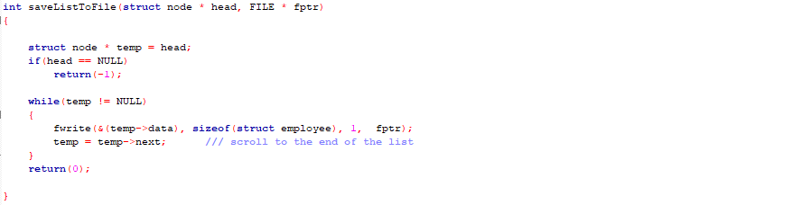

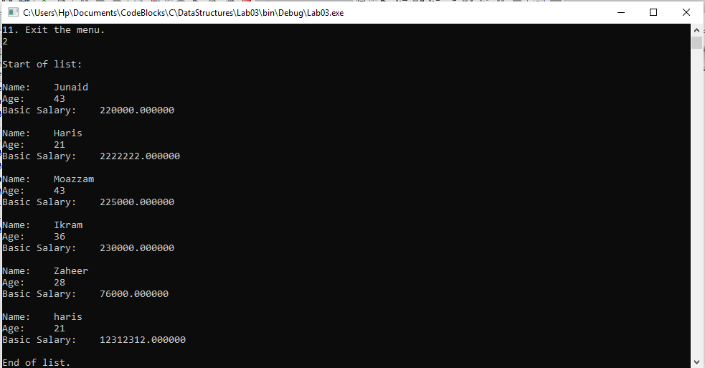The Result of the following code is attached below:

------------------------------

THE END